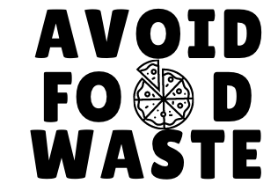

The average person in the U.S. wastes 20 lbs. of food per month! Only take what you need from catering.

[SHOW] donates any untouched food to local non-profit organizations. Help us reduce waste and our environmental footprint and….

**ONLY TAKE WHAT YOU NEED**

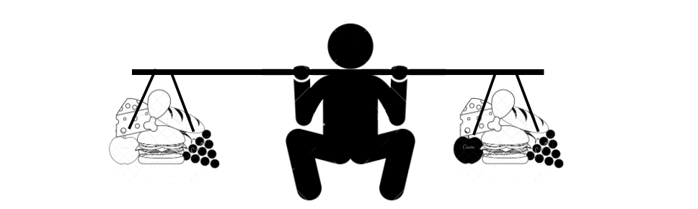

**If the U.S. wasted just…**

**5% LESS FOOD**

**it would be enough to feed**

**4 MILLION AMERICANS**

**ONLY TAKE WHAT YOU NEED**

**DID YOU KNOW?**

**wastes 20 lbs. of food per month!**

**The average person**